# **SQL LIBRARY WEBSITE**

By Mohamad Aaliy Ezran bi Mohamd Zafran 1K5

Software Used : HeidiSQL

## 1. Table Making

### 1.1 : Create Database File

#### Code



#### Results



#### Explanation

CREATE DATABASE allows a database to be made if it does not exist. The name of the database is determined in the CREATE DATABASE command.  
  
The USE command allows you to apply the code written into the database given.

### 1.2 : Create Table

#### Code

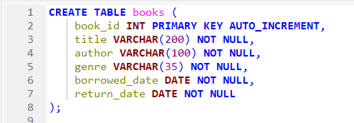

#### Results

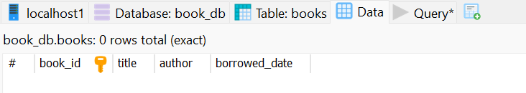

#### Explanation

CREATE TABLE (name) is used to create a table with that name. INT means it must be filled with an integer, PRIMARY KEY is used to identify each row in the table and AUTO_INCREMENT automatically increases the integer when a new row is added.

VARCHAR(#) command is used to make a variable have a maximum of # characters. NOT NULL is used to state that the column cannot be empty. DATE is where date format is used, but in YYYY-MM-DD format.

### 1.3 : Editing the Table

#### Code

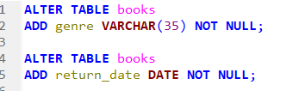

#### Results



(Column Added)

#### Explanation

ALTER TABLE allows the programmer to change the table in terms of column, varchar, etc. ADD after ALTER TABLE is used to add a new column to a table.

## 2. Data Collecting and Queries

### 2.1 Data Entry

#### Code

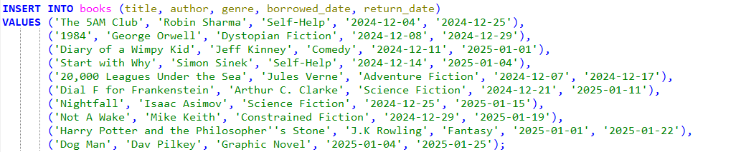

#### Result

None (because one command is missing)

#### Explanation

INSERT INTO is used to input the data in the table that is made earlier. All VALUES must be written in the set format (top line, can be different). VALUES in the data that is in the row.

### 2.2 Display Data

#### Code



#### Results

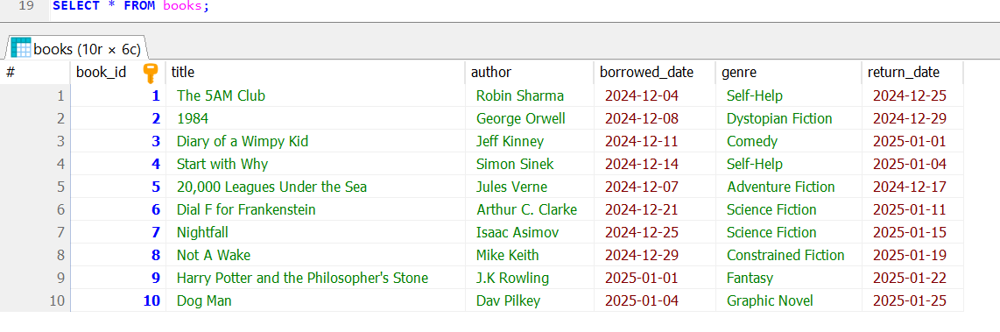

#### Explanation

SELECT command is a command where certain column are chosen to be displayed, whereas SELECT * selects all columns. The SELECT command is often followed by a FROM command which states what table the command has been implemented.

### 

### 2.3 Filter Data

#### Code and Results

| Filter By | Code | Results (Duplicated Data ) |
| --- | --- | --- |
| Author Name |  |  |
| Borrowed on specific day |  |  |
| Borrowed after specific day |  |  |
| Book ID |  |  |

#### Explanation

The WHERE command is used to specify a condition. There are 3 signs, exactly (=), at most (<=) and at least (>=).

## 

## 

## 3. Data Modification

### 3.1 Update Data

#### Code

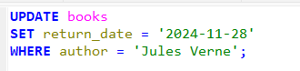

#### Results

Before

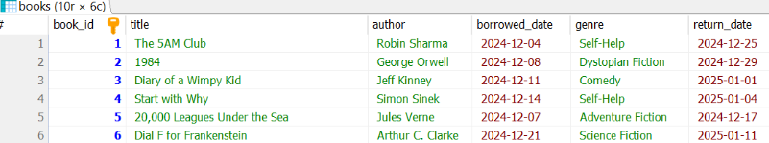

After

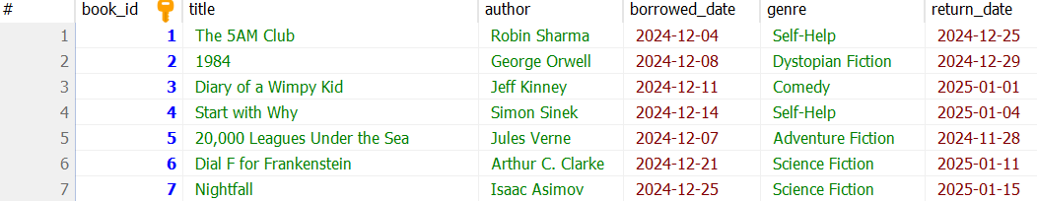

#### Explanation

UPDATE is used to update a certain input in the database, and SET is used to change a certain input in the table.

### 3.2 Delete Data

#### Code

#### 

#### Results (after putting in new data)

#### 

#### 

#### Explanation

### 3.3 Re-add Hard Deleted Data

#### Code

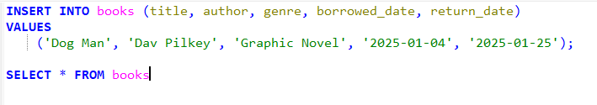

#### 

#### Results

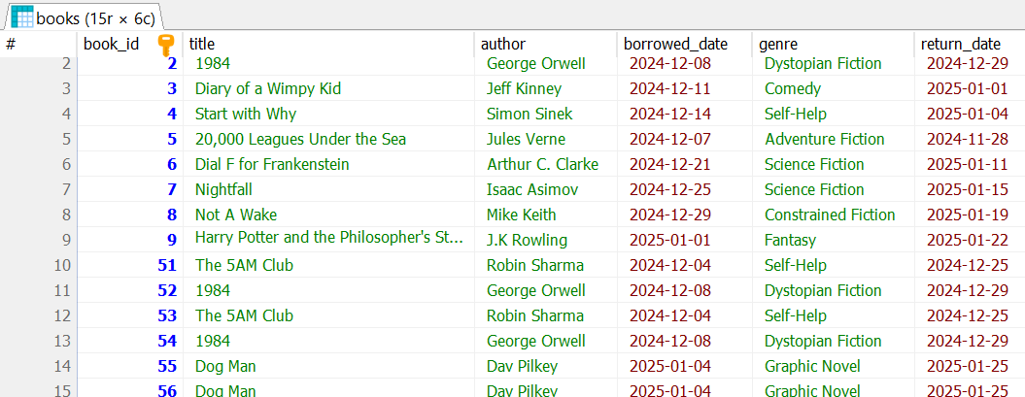

## 3.4 Soft Delete

#### Code

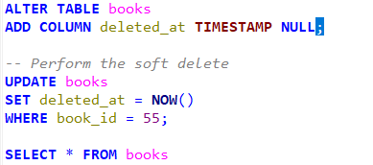

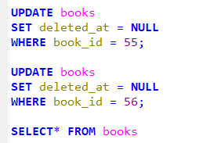

#### Result

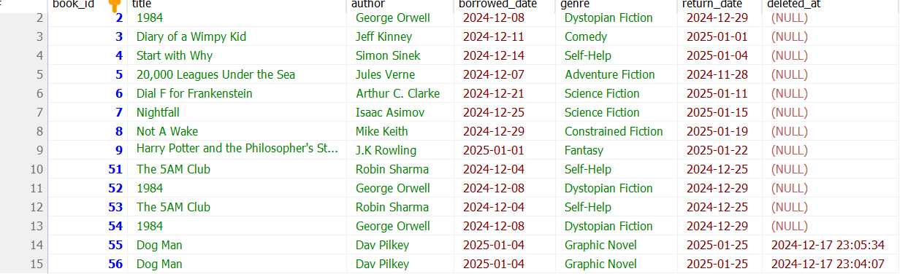



#### Explanation

UPDATE books specifies that you want to modify the data within the books table.

SET deleted_at = NOW()\ sets the value of the deleted_at column to the current timestamp (using the NOW() function). This effectively marks the record as deleted without physically removing it from the table.

SET deleted_at = NULL sets the value of the deleted_at column to NULL. Since NULL typically represents the absence of a value, setting deleted_at to NULL effectively removes the "deleted" flag from the record.